Figure 1: Original-Scale Model Residual Plots
SalePrice ~ GrLivArea + Neighborhood + GrLivArea * Neighborhood
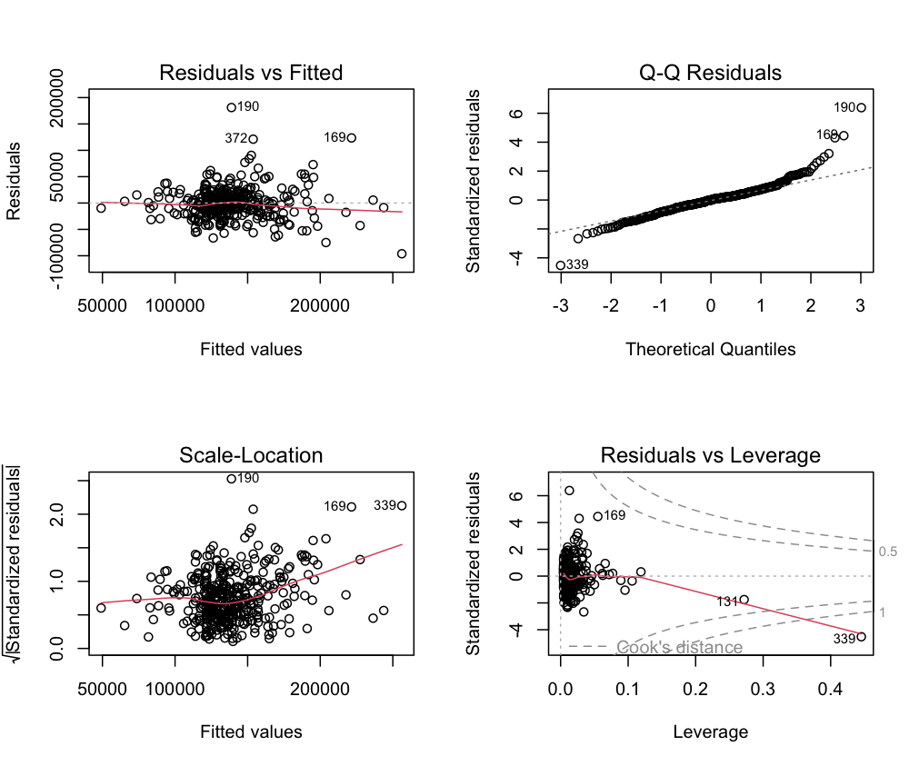
Figure 2: Final Log-Scale Model (Without Outliers) Residual Plots
Log(SalePrice) ~ GrLivArea100_c + Neighborhood + GrLivArea100_c * Neighborhood
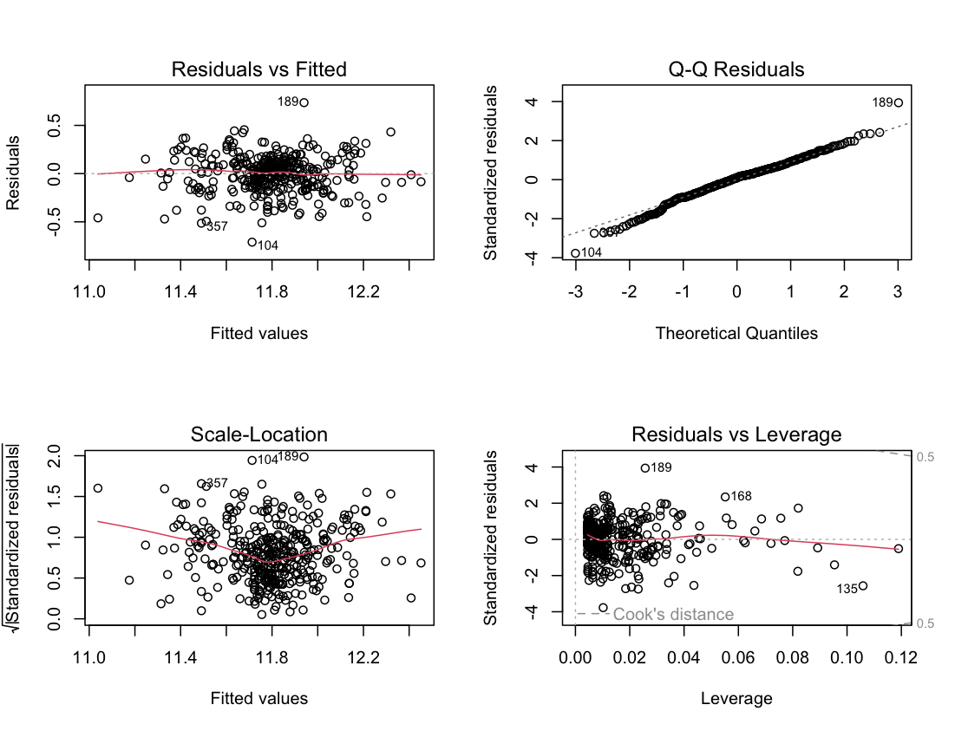

Figure 3: Final Log-Scale Model (Without Outliers) Summary Coefficients
Log(SalePrice) ~ GrLivArea100_c + Neighborhood + GrLivArea100_c * Neighborhood

